**1.Display the subject code,and total marks for every student.**

select student_code,(sum(subject1)+sum(subject2)+sum(subject3)) as total_marks

from student_marks

group by student_code

order by student_code;

**OUTPUT:**

[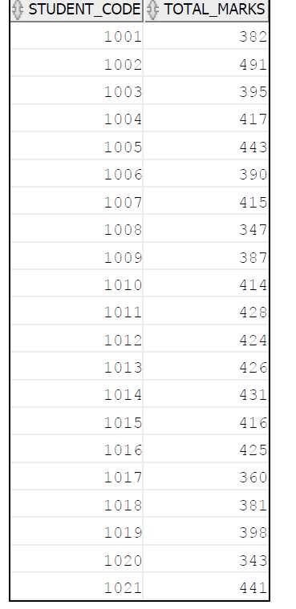](https://github.com/Umakant03/KPI-Partners/blob/main/Case_Study/Week_3/case1.png)

**2.List the name and designations of the staff who have joined before Jan 2005.**

select staff_master.staff_name,designation_master.design_name

from staff_master

join designation_master

on staff_master.design_code=designation_master.design_code

where staff_master.hiredate < '01-01-2005';

**OUTPUT:**

[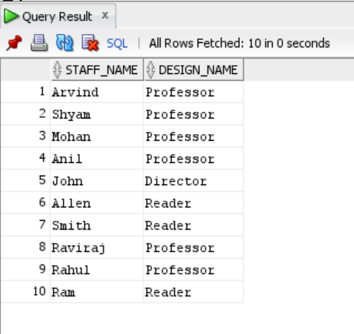](https://github.com/Umakant03/KPI-Partners/blob/main/Case_Study/Week_3/case2.png)

**3.Display the employees for whom the manager is not allocated.**

select * from emp

where mgr is null;

**OUTPUT:**

[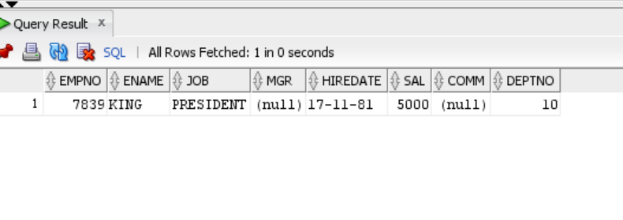](https://github.com/Umakant03/KPI-Partners/blob/main/Case_Study/Week_3/case3.png)

**4.Display the details of the books that is not been returned and expected return date was monday.**

SELECT EXTRACT(day FROM book_expected_return_date) "Month"

from book_transactions;

select * from book_transactions;

**5.check the date of birth of the students and display only those students who were born on saturday or sunday.**

select * from student_master

where trim(to_char(student_dob,'Day'))='Saturday' or trim(to_char(student_dob,'Day'))='Sunday';

**OUTPUT:**

[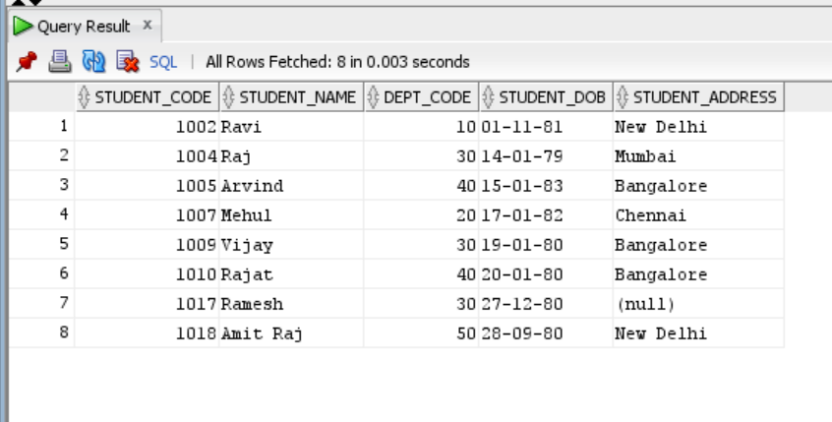](https://github.com/Umakant03/KPI-Partners/blob/main/Case_Study/Week_3/case5.png)

**6.Display the staff name and hire date (through this date find out the day!).create a new column as DAY in the result nd sort it to start from monday.**

SELECT ename, to_char(hiredate, 'fmDAY') AS "Day"

FROM emp

ORDER BY (hiredate - next_day(hiredate, 'MONDAY')

**OUTPUT:**

[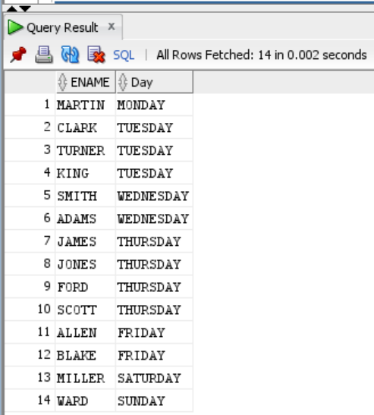](https://github.com/Umakant03/KPI-Partners/blob/main/Case_Study/Week_3/case6.png)

**7. display manager name, manager code and salary of the lowest paid staff in that manager's group Exclude that group where the salary is less then 10k. Display other records in desc order.**

select staff_name,mgr_code,staff_sal

from staff_master

where staff_sal>10000

order by staff_sal desc;

**OUTPUT:**

[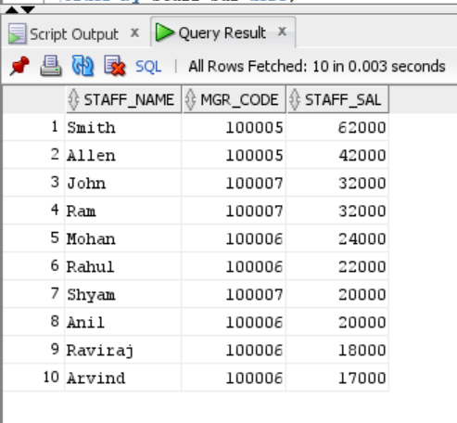](https://github.com/Umakant03/KPI-Partners/blob/main/Case_Study/Week_3/case7.png)